Full Name: Thanh Tung Le
Student ID: 991751027

For Final Project, I choose Option 2 and work Individually

Option 2: Real-Time Financial Trading App

Overview
This project is about creating an app where traders can log in, buy and sell stocks, see live market prices, and get alerts in real-time. It is built using Amazon Web Services (AWS) so it can run fast, stay secure, and handle a lot of users at the same time.

Why I am choosing this project?
- This project integrate with many Cloud Service, which I have interesting the most
- I always want to create a real hand-on project base on what I learned in Cloud and Java
- I have some AWS Certificate, but I did not have chance to prvatice it at all
SO, here is why I choose to use Java/SpringBoot to do my Final Project

Technology I will use for this project:
- Frontend
- Angular (Trader Dashboard)
This is the website that traders use. It shows live market prices, portfolio updates, and alerts. Traders can log in here and place trades directly from the dashboard.

- Backend (APIs)
- Spring Boot (APIs for trading, portfolio, and alerts)
These are the main programs that handle all the work in the system. They manage trades, keep track of portfolios, and send alerts. They are written in Java Spring Boot and run inside containers. The frontend talks to these APIs.

- Compute and Networking
- Docker with ECS
Docker puts each program into a container, which is like a small box. ECS or EKS runs these containers on AWS. This makes it easy to run many copies of the same program when needed.
- Application Load Balancer (ALB)
This service chooses which server or container will handle a trader’s request. It balances the traffic so no single server gets overloaded.
- VPC (Virtual Private Cloud)
This is a private network in AWS. Some parts are public, like login, while sensitive parts such as APIs are kept private.

- Security
- OAuth2 with AWS Cognito
This is used for logging in and signing up. It makes sure the login is safe by adding options like two-factor authentication. Once logged in, the user gets a secure token that allows them to use the app.
- IAM (Identity and Access Management)
This controls which services can access specific resources. For example, only the trading API can send trade data to a queue.
- Security Groups
These act like firewalls. They decide which parts of the system are allowed to communicate with each other.
- KMS (Key Management Service)
This service manages encryption keys. It makes sure all stored data is safe and encrypted.

- Monitoring and Scaling
- CloudWatch
This service monitors the app. It shows information like CPU usage, memory use, and errors. It can also send alarms if there are problems.
- Auto Scaling
This adds more servers when the app is very busy, such as during market spikes, and reduces servers when there are fewer users. This saves money and keeps the app fast.

Architecture Diagram:
Here is the AWS Architecture diagram with SpringBoot that I take 1 hour to complete
This Architecture have:
- Cognito: Authentication
- Auto Scaling Group: for scalability
- Load Balancer with multiple Availability Zone to have High Availability
- SNS + SQS/Kafka: for message broker, decouple the application
- Docker + ECS Fargate: for container and serverless
- Security: KMS for managing keys and IAM for authorize access

I would love to add more services like
- Route53 for DNS
- Global Accelerator for global users
- CloudFront for caching and content delivery
- Lambda for event-handler
- Kinesis Data Stream and Kinesis Data Firehouse for get data near real-time
Here is the idea of my project with Architecture
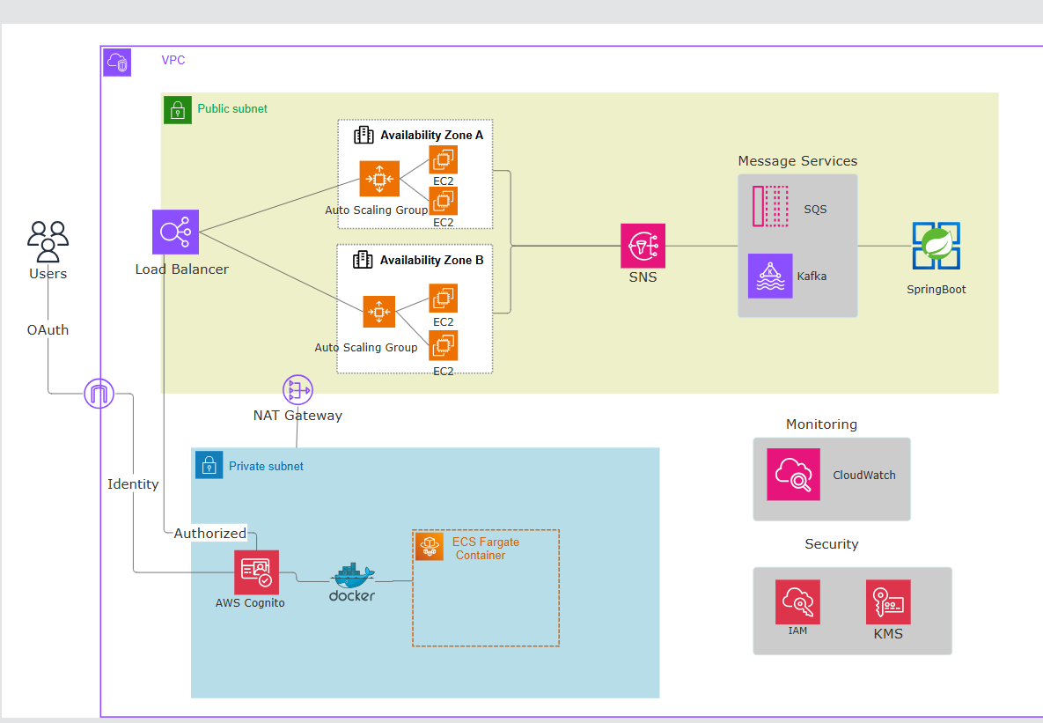
____END_____

